SELECT nama_obat, nama

FROM obat O

JOIN manufaktur M ON O.id = M.id

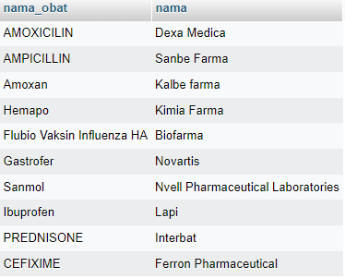

SELECT nama_obat, qty

FROM obat_detail D

LEFT JOIN obat O ON D.id = O.id;

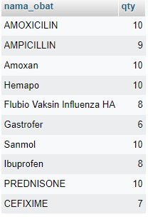

SELECT nama_obat, qty

FROM obat_detail D

LEFT JOIN obat O ON D.id = O.id WHERE qty = 10;

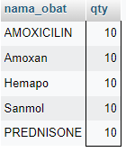

SELECT nama_obat, qty

FROM obat_detail D

RIGHT JOIN obat O ON D.id = O.id ORDER BY qty;

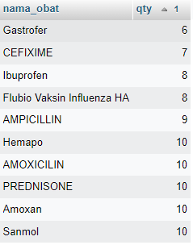

SELECT nama_obat, nama

FROM obat O

JOIN manufaktur M ON O.id = M.id WHERE nama_obat LIKE '%amox%';

